Introduction

# Cellular architecture and electrical properties of neurons

## Building blocks of the brain

Neurons are the functional units of the brain. They receive inputs, transform them, and produce output signals targeting other neurons.1 Common cellular structural elements permit neuronal function (shown in schematic A below).

The soma (cell body) of the neuron contains the nucleus and surrounding cytoplasm, which encases neuronal organelles. In the cytoplasm, ribosomes and endoplasmic reticula synthesize proteins and other macromolecules that provide structural integrity and maintain neuronal homeostasis. The soma receives electrical inputs travelling along apical and basal dendrites.

Primary dendrites extend from the soma and branch out distally forming the dendritic tree. Along some dendrites, small cytoplasmic pedunculations called dendritic spines receive excitatory synaptic input and begin signal processing.1 Neuronal populations can be classified according to the presence of dendritic spines and other dendritic morphological features such as surface area and number of branches.2 Dendritic branches narrow and contain fewer cellular organelles as the tree lengthens.

Unlike the soma and dendrite, axons lack cellular organelles capable of synthesising macromolecules. The axon is narrow with a uniform diameter along its length. Should the summation of incoming inputs reach a threshold, the neuron discharges an action potential down its axon. The terminal axon portion from one neuron communicates with a dendrite of another forming a synapse, the basis for neural signal transfer.

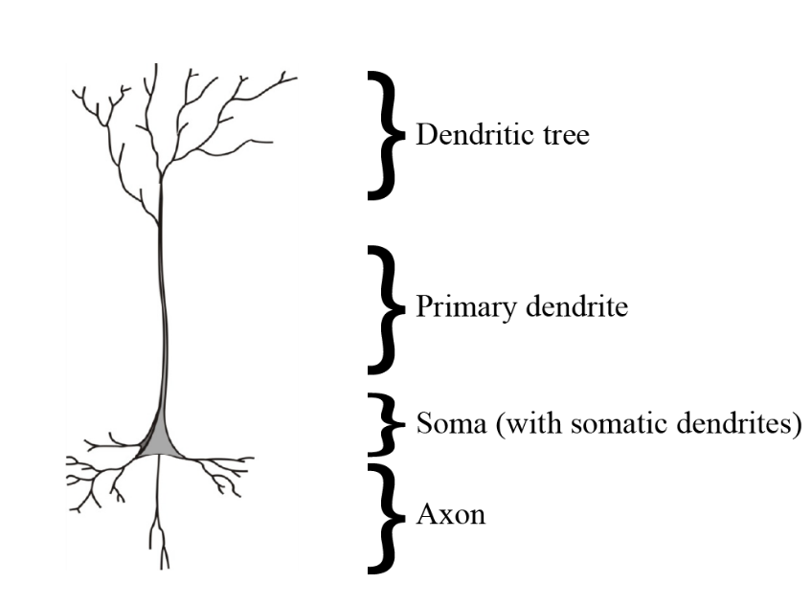

Schematic A – Structural elements of a neuron

## Neural signal propagation

Synapses interface two communicating neurons and translate between chemical and electrical signals. An activated pre-synaptic neuron releases chemical neurotransmitters into the synaptic cleft which bind to transmembrane receptor proteins on the post-synaptic neuron. This neurotransmitter-receptor interaction causes a conformational change to the receptor protein such that it can act as a channel for rapid ion flux between the extracellular environment and the neuron.

The magnitude and direction of ionic flux determines the effect of neurotransmission on the post-synaptic membrane. Ionic motion across the membrane produces either an excitatory signal by increasing the membrane potential (depolarizing) or an inhibitory signal by decreasing the membrane potential (hyperpolarizing). Tightly control of excitatory and inhibitory signalling underpins precise neural communication. Dysfunction in ionic homeostatic mechanisms can affect an imbalance of excitation and inhibition resulting in neurological disorders.

## Ionic homeostasis in neurons and the Nernst Potential

Ionic homeostasis is the ability for of cell to have stable ionic concentrations and adjust to external changes through self-regulating control mechanisms. Uniform ionic concentrations ensures that most neurons remain at rest, while only specific neurons are activated. Ionic homeostasis is maintained by a semipermeable cell membrane that acts as a gatekeeper for most ionic fluxes.

Ionic motion across a semipermeable membrane is governed by several forces. *Diffusion* refers to the movement of ions from a region of high ionic concentration to a region of low concentration. Water movement follows ionic flux across the membrane via *osmosis* such that the osmoneutrality is maintained. Lastly, *drift* is the flux of charged molecules that occurs due the local electrical field. These electrical forces set up electroneutrality across the membrane resulting in a balance of positive and negative charges on either side. The net flux of ions therefore is a combination of both chemical and electrical forces.

The *Nernst-Planck Equation* (NPE) (equation 1.1) is used to calculate the net flux for a particular ion. The equation makes use of the Einstein Relation which states that fluxes of diffusion and drift are additive in the same medium. Therefore, the NPE combines Ohm’s Law for Drift and Fick’s Law of Diffusion as shown in (1.1) below.

(1.1)

$$I= -\frac{μz^{2}}{N_{A}}F\left[C\right]\frac{dV}{dx}- \frac{μz^{2}}{N_{A}}RT\frac{d[C]}{dx}$$

In (1.1), *I* is the current, *µ* the ionic mobility constant for a particular ion, *z* the valence of the ion, *NA* is Avogadro’s number, *F* is Faraday’s constant, [*C*] is the ionic concentration, *V* is the voltage, *x* is the distance between the potentials, *R* is the universal gas constant and *T* is the temperature. The negative sign in both terms indicate that the direction of current flow is opposite to the concentration/voltage gradients.

In steady state (resting) conditions, the net flux (*I*)for an ion is equal to zero. Therefore, equation (1.1) can be rearranged and solved for V, referred to as the *Nernst Equation* (1.2). The Nernst potential, also known as the equilibrium potential or reversal potential for a particular ion, is the voltage across the membrane (V*m*) at which the electrical forces balance the osmotic forces3.

(1.2)

In (1.2), *Eion* is the reversal potential for a particular ion, [*ion*]*o*is the concentration of the ion outside the membrane (extracellularly) and [*ion*]*i* is the intracellular ion concentration. The Nernst Equation provides the reversal potential for a single ion, however, cannot determine the potential of the entire membrane.

## Membrane potential and ionic driving forces

Two traditional ways have been used to calculate the resting membrane potential (V*m*), the “charge-sum” and “charge-difference” approach. The “charge-sum” approach entails setting the summation of the currents to equal zero ($\sum{I_{Capacitance}+I_{ion}=0) }$ which becomes a differential equation that is solvable4. The solution however requires the initialization values to be known. The “charge-difference” method5 provides the same solution for Vm, without requiring initialization values, by utilizing the formula for capacitance ($C_{m}=q/V_{m})$. Charge (*q*) is the difference between the extracellular and intracellular charges. A neuron existing in a neutral extracellular environment will have an extracellular charge of zero. The intracellular charge is the sum of the internal ion concentrations multiplied by their valences. This charge is multiplied by Faraday’s constant (F) to convert mol to coulombs.

(1.3)

$$V_{m}= \frac{F \left({\left[{Na}^{+}\right]}_{i}+{\left[K^{+}\right]}_{i}-{\left[{Cl}^{-}\right]}_{i}+{z[X^{-}]}_{i}\right)}{C_{m}}$$

In the charge-difference equation, [*Na*+]*i* represents sodium concentration, [*K*+]*i* is the potassium concentration, [*Cl*-]*i* is the chloride concentration. [*X*-]*i* refers to the concentration of impermeant anions, with a valency of *z.*

The membrane potential (*Vm*)of a neuron at rest lies within the range of - 62 to - 75mV, indicating that the internal environment of the neuron contains more negative charges than the external environment. Table 1 shows the concentration gradients across the membrane which set up the membrane potential. The driving force (DF) of an ion is equal to the difference between the membrane potential and its equilibrium potential (*Vm* -*Eion*) and is the net force acting on the ion at rest. To calculate the ionic current for a particular ion (*Iion*) across the membrane due to its driving force Ohm’s law can be used (I = V/R), shown in equation (1.4). $$I_{ion }=g_{ion}\left(V_{m}-E_{ion}\right)$$

The inverse of resistance (1/R), conductance (*gion*), is typically preferred in neuroscience as it intuitively relates to how easily an ion can cross the membrane. This is determined by the number of open ion channels at a given time. Altered membrane conductances to specific ions at discrete time intervals provides increasing complexity to neuronal dynamics and provides the basis for synaptic modelling. At rest neuronal membranes are highly permeable to K+ and Cl- and far less permeable to cations such as Na+ and Ca2+.

(1.4)

|  |  |  |  |
| --- | --- | --- | --- |
| Ion | Intracellular  concentration (mM) | Extracellular concentration  (mM) | Equilibrium  potential (Eion)  (mV) |
| Sodium (Na+) | 5-15 | 145 | 90.7 - 61.1 |
| Potassium (K+) | 140 | 5 | - 89.7 |
| Chloride (Cl-) | 4 | 110 | - 89 |

## Maintenance of membrane potential and cell volume

Neurons create an electrochemical gradient to establish a non-zero resting membrane potential required for current flow. This is achieved by two main mechanisms, active transport and the Donnan equilibrium1.

Active transport refers to membrane proteins that act as pumps capable of moving ions against their electrochemical gradients in exchange for energy in the form of ATP. The sodium-potassium ATPase (Na-K ATPase), the most crucial active transport mechanism, pumps three sodium ions out of the neuron in exchange for two potassium ions which enter. The fewer number of positive charges inside the neuron results in a resting membrane potential which is negative. The metabolic energy currency, ATP, is hydrolysed for the pump to function. Neurons which are no longer metabolically active do not produce ATP leading to a loss of the electrochemical gradient critical to maintain a negative resting membrane potential.

In addition to active transport, a non-zero membrane potential can be established by the Gibbs-Donnan Effect, which describes the broad implications impermeant anions (IA) have on cellular compartments enclosed by a semi-permeable membrane6,7 . Impermeant anions are anionic species trapped in a cellular compartment creating an osmotic force. Such ions result in water influx which provides turgidity to the intracellular compartment. This mechanism is ATP-independent, however without the Na-K ATPase uncontrolled cell swelling and lysis would occur. In neurons with fixed Na-K ATPase densities, the resting membrane potential of the neuron is determined solely on IA average charge.5 Therefore, precise interplay between IA and the Na-K ATPase are the key regulates of neuronal volume.

Impermeant anions have an electrochemical influence beyond their effects on cell volume. Intracellular IA require cations of equal net ionic charge to enter the neuron to ensure electroneutrality. The Donnan equilibrium is the electrochemical gradient resulting from intracellular impermeant anions. Impermeant anions affect more permeable ions by drawing in K+ and expelling Cl- helping to create the major concentration differences observed across the membrane. The Donnan Potential8 is the potential caused by Donnan forces described by the equation (1.5)

(1.5)

$$ψ= \frac{RT}{zF}\sinh^{-1}{\frac{ρ}{2zFc}}$$

*R, T* and *F* are constants mentioned above, *z* is the valence of the impermeant ion, *ρ* the charge density, and *c* the molar concentration. The charge density is the product of the charge multiplied by Faraday’s constant (*ρ = Q*·*F*). Appreciating the distribution, concentration, and charge of impermeant anions is of importance to understand the electrical properties of neurons.

# Impermeant anions

## Properties of impermeant anions.

The three major anion species in the brain are chloride (Cl-), bicarbonate (HCO3-), and impermeant anions(IA). Impermeant anions refers to a heterogenous milieu of macromolecules unable to traverse the cell membrane. These include sulphates (SO4-), phosphates (PO4-), phosphorylated molecules such as ribonucleotides, metabolic end products and other intracellular proteins (such as actin and tubulin) and which are negatively charged at physiological pH. 9,10,11 The core IA properties of functional importance are 1) concentration, 2) charge, and 3) distribution.

Of the three main intracellular anions, HCO3- ion concentrations are relatively fixed to maintain physiological pH within a narrow range of 7.35 to 7.45. Chloride and IA on the other hand can have significantly varied concentrations. To ensure electroneutrality in the neuron the concentrations of Cl- and IA are intrinsically linked and increases to one anion generally necessitates a decrease in the other.

The average charge of impermeant anions is another variable of importance. There are approximately 500 protein types in the CNS (contributing to the milieu of IA), with the majority having an isoelectric point (pI) less than a pH of 7 12. Therefore, at physiological pH most proteins will donate protons and exist as a weak base with a negative charge. The charge of IA likely varies on the local pH and abundance of phosphate among other factors. The impact of local variations in the charge of impermeants is under-researched, however has functional importance in neurons. For instance, in neurons with fixed Na-K ATPase densities, cell volume is determined solely by IA concentration and charge. 5

Another understudied subject in neurophysiology is the distribution of IA. As the cellular machinery for protein synthesis is scattered non-uniformly throughout dendrites and the soma it is likely that proteins are heterogeneously distributed in cytoplasm of neurons. Moreover, macromolecules can move within the neuron due to cytoplasmic transport mechanisms. Extracellularly, sulphate groups attached to proteoglycans are an impermeant anionic species forming the scaffold of the extracellular matrix. Proteoglycan manipulation has been shown to affect cell volume, membrane potential and neuronal excitability.

The diverse functions of IA can be categories into two broad groups. Firstly, functions related to cell structure, volume, and homeostasis. Proteins implicated in enzymatic repair, proteolytic cleavage, intracellular transport, and ion channels/receptors comprise the most well studied and understood IA that contribute to essential neuron homeostatic mechanisms. Secondly, and of focus for this thesis, are functions of IA related to electrical signalling in the brain

## Inhibitory signalling

Anions, in particular Cl- and IA, play a crucial role in inhibitory signalling in the brain. Synaptic inhibition is vital for producing precise oscillations in neural activity allowing for neural coding while also preventing widespread excitation in recurrently connected neural pathways.13. To better understand and treat these conditions a clear knowledge of the homeostatic control mechanisms for inhibitory signalling is needed.

Gamma-aminobutyric acid (GABA) is the primary inhibitory neurotransmitter in the CNS and relies on anions for its effects. GABA mediates fast synaptic inhibition by binding to GABAA receptors, which when bound act as transmembrane ion channels permeable to Cl- (and to a lesser extent HCO3-).14 The Cl- concentration gradient between the internal and external environment determines the GABA reversal potential (EGABA) and subsequent driving force for Cl- . The direction of Cl- flux through GABAA receptors underpins the function of GABAergic signalling

The inward flux of Cl- through GABAA offers a power mechanism of inhibition in the brain if the intracellular Cl- concentration remains low.15 Minor increases in Cl- concentrations can lead to Cl- extrusion through GABAA receptors and a paradoxical depolarizing current leading to pathological excitatory activity.16 Appreciating the determinants of Cl- concentration is critical as minor concentration differences can result in major functional implications in the brain.

## Impermeant anions and inhibition

Inhibitory signalling is reliant on tightly regulated Cl- concentration gradients, yet the determinant for this gradient is debated. More specifically neuroscientists have struggled to discern whether transmembrane cation-chloride cotransporters (CCCs)17 or impermeant anions(IA) are more responsible for setting up chloride gradients and hence the GABA reversal potential (EGABA).

Experimental work on murine brain slices performed in the Stalely lab by Glykys et al.9 suggest that IA play a more important role in establishing neuronal Cl- concentration. They observed that by altering the balance between intracellular and extracellular IA concentrations, Cl- concentrations were affected. Moreover, inhibiting CCCs only had minor effects on Cl- concentrations.

Contrasting findings from the Raimondo lab18 showed that increased IA concentrations did not impact Cl- concentration due to the Donnan equilibrium and subsequent cell swelling. Chloride concentration changes were observed only when the average charge (and not concentration) of IA was manipulated. This finding is in-line with the theoretical model proposed by Fraser and Huang (2004).5 It is postulated that perhaps the observed effects by Glykys et al.9 may be due to modifications to the average charge of IA because of the staining methods used, as well as the perfusion of organic acids used for Cl- imaging which could have altered pH balance.

Although IA average charge and CCCs are both responsible for establishing Cl- concentration gradients (and subsequently EGABA), IA charge manipulation did not affect Cl- driving forces, while alteration to CCCs did.18 This phenomenon is backed up by theoretical models which demonstrate IA also play a key role in establishing the membrane potential. Predictably if EGABA and Vm varied in proportion to changing IA average charge there should be no alteration to the Cl- driving force.

## Non-isopotential neurons

Although the mechanisms that establish EGABA are known, it has been observed that interneurons firing onto a single pyramidal neuron can have varied EGABA. In a summary of 20 published studies, an EGABA variance of ±25mV was shown between interneurons. Such variance spans the domain of EGABA functions from hyperpolarizing to shunting to depolarizing.11

Investigating this phenomenon, the Staley laboratory has recently shown using experimental methods that Cl- microdomains (subcellular regions of varied Cl- concentrations) exist and correlate with regions of varied EGABA.11

A hypothesis for how such Cl- microdomains may arise is that IA are heterogeneously distributed along the length of the dendrite.It is plausible that a variable distribution of subcellular IA could occur due to microtubule-based protein trafficking along dendrites as well as scattered protein synthesis19,20. Moreover, a non-uniform average charge distribution of IA could result in varied EGABA and Vm such that driving force is not affected. 18 Schematic B below demonstrates how a segment of a dendrite with distinct chloride microdomains can have uniform Cl- driving forces.

The proposal that of non-uniform IA and EGABA directly contradicts established models of dendrites such as Cable Theory which adopts fixed ionic reversal potential across the length of the dendrite at rest – an assumption known as isopotentiality. Although a non-isopotential neuron is theoretically plausible, there are no experimental or computational studies showing how heterogenous subcellular distributions of IA can result in Cl- microdomains and variances in EGABA. Moreover, how inhibitory signalling may differ in a non-isopotential neuron versus and isopotential neuron is unknown.

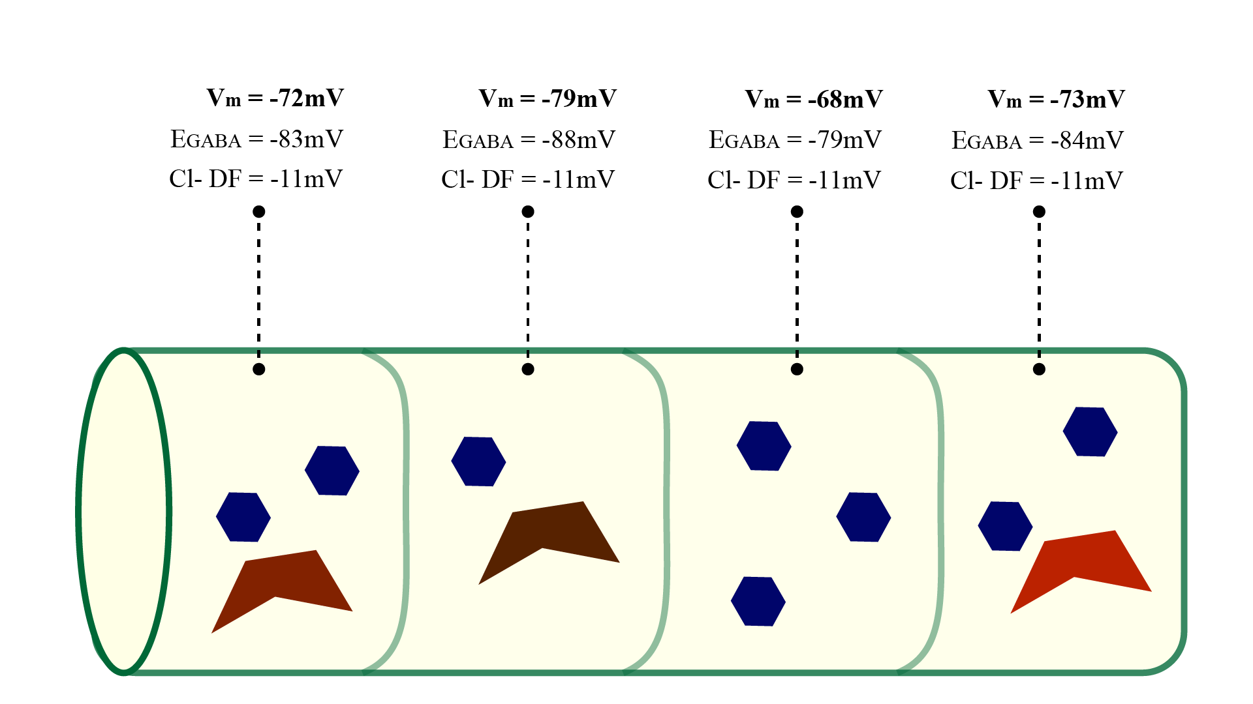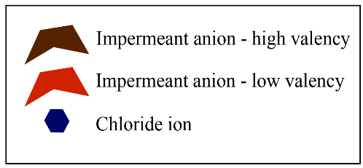

Schematic B – Chloride microdomains along a dendritic segment with stable driving forces (DF) arising from a scattered distribution of impermeant anion average charge.

## Studying impermeant anions

Experimental methods to study the impact of impermeant anions in physiological and diseased states is challenging.

Single cell RNA sequencing provides cell-type specific information regarding the type and quantity of mRNA transcripts giving indirect insight into the protein composition of a single cell however it is unable to determine the precise subcellular location of the proteins produced nor give insight into the post-translational modification and electrophysiological significance of such proteins.

A novel solution to this problem is the use of Multiplexed Protein Maps (MPMs)20. The 4i indirect immunofluorescence protocol combines utilizes protein specific labelled antibodies and computer vision to identify the subcellular location of proteins and nucleic acids in single cells, as well as determine whether they are phosphorylated or not, and what phase of the cell cycle they are occurring in. This protocol provides high spatial resolution however has limitations due to fluorescent artefacts, challenges of antibody specificity, and time costs to conduct such experiments.

Computational models of dendrites can overcome many of the challenges of laboratory-based methods to understanding the functional implications of impermeant anions in neurons.

Variations in the valence and concentration of local impermeant anions may result in difference in the electrical field leading to non-isopotential compartments. Computational models often assume a fixed charge and concentration for impermeant anions in both the intra and extracellular environments, however in reality these parameters may vary.

Although some work has been done to explore the osmotic and electrical effects of impermeant anions there are still many unanswered questions. It remains unknown whether spatial inhomogeneities in the distribution of impermeant anions plays a role in neural function. Moreover, the impact of impermeant anions in an electrodiffusion based model has not yet been adequately explored. In my thesis I will investigate this unknown territory whilst also considering the effect of impermeant anions in disease processes.

Redistribution of chloride intracellulary on fast time scales … See Doyon pg 2

# Modelling dendrites

Experimental models trying to isolate IA in the subcellular space is challenging due to the difficult in recording electrochemical signals along narrow spatiotemporal scales. Redistribution of chloride can occur at rapid time scales along the dendrite while mapping the precise distribution of IA whilst simultaneously gathering electrical signals has yet to be performed.21 To overcome these obstacles theoretical/computational approaches are more feasible.

Several such models have been proposed to predict neural functioning, each of which balance detail with abstraction. On one extreme of the spectrum, black-box models focus solely on the input, processing, and output (functional) aspects of neurons while ignoring the role structural morphology plays. These models are useful when trying to predict neuronal spiking frequencies based on varied inputs for example however are limited in describing effects related to neural structure such as the distribution of IA.

Contrastingly, detailed morphological models most accurately account for neuronal morphology such as dendritic branching patterns and axonal geometries. Unusual dendritic morphologies are present in disorders such as Down’s syndrome, senile dementias, and epilepsy1 , therefore when attempting to study such conditions these more detailed models may be more appropriate. However, not all aspects of morphology are necessary for understanding the dynamics of a single neuron and efforts to incorporate detailed structure may be redundant22. Equivalent circuit multi-compartmental models strike a balance between detail and abstraction.

## Equivalent circuit models and Cable Theory

Equivalent circuit models liken the core electrical properties of neurons to electronic components in a circuit, with each component in the circuit representing an electric property of the neuron.23

The semipermeable plasma membrane is modelled as a capacitor based on the dielectric properties of the membrane with ion accumulating on either side of it. The capacitance of most neuronal membranes is approximately 1µF/cm2.1

Ion channels both permit and prevent ions crossing the membrane thus are modelled as resistors with variable conductances for specific ions. The conductances of these channels can vary with time and voltage, for instance at a synaptic junction when neurotransmitters bind causing post-synaptic ion channels allow ionic flux.

Internal resistance (*ri*) is the resistance to the flow of ions due to the cytoplasm (and intraneuronal structures) along the length of the dendrite. The dendrite length (*x*) and cross-sectional area (*A*) are the determinants of the internal resistance (thin and long neurons having the greatest the internal resistance). An internal resistivity constant (*rL*) is used as a scaling factor and is usually in the range of 1-3kΩ mm. Dendrites that are long and thin are termed electronically compact, and it is assumed that they have relatively constant internal resistance and thus a constant membrane potential along the length of the dendrite (isopotential)24.The formula below is used to calculate the internal resistance of a length of dendrite.

(1.5)

$$r_{i}=\frac{r_{L} x}{A}$$

Lastly, the driving force of a particular ion is modelled as a battery as this provides the potential difference that sets up ion flow.

Cable Theory extends equivalent circuit models by considering how the electrical signal attenuates as it propagates from the dendrite to the soma thus ensuring that dendritic diameter, dendritic length, and intracellular axial resistance are accounted for. Schematic C below demonstrates how sequential equivalent circuits in series can be combined and modelled as a cable.25

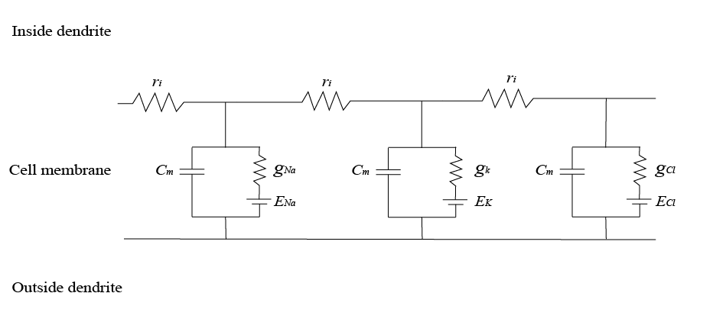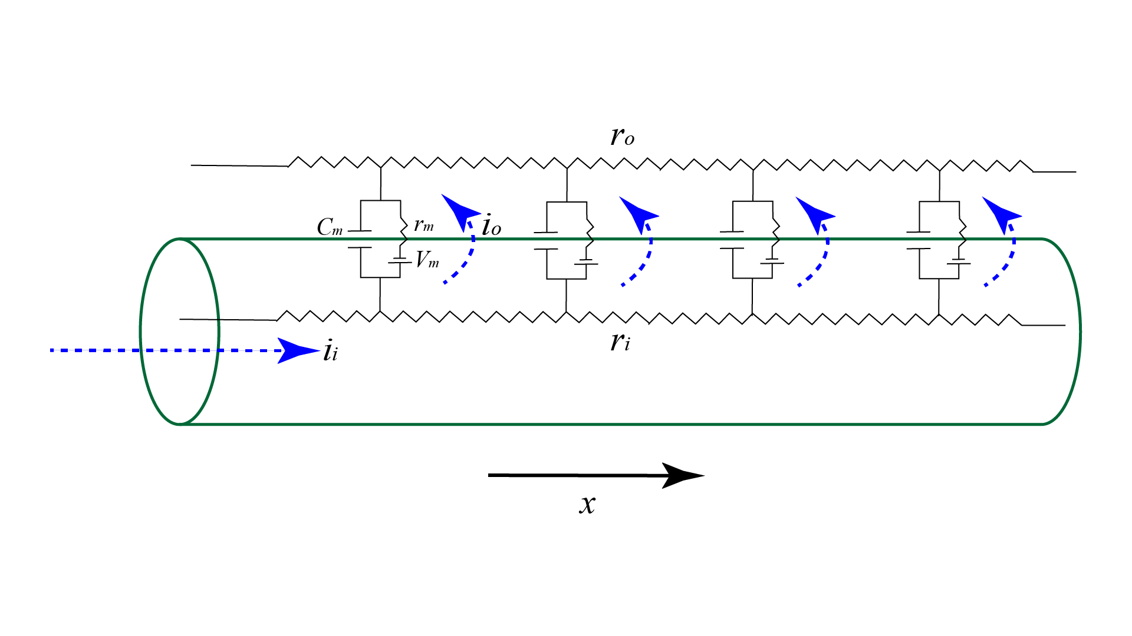

**Schematic C.** Electrical representation of the relationship between the equivalent circuit model and Cable Theory. Cm = Membrane capacitance, Vm = membrane voltage, rm = membrane resistance, ri = internal (axial) resistance, ro = outward resistance , ii = inward current, io= outward current, gna = conductance for sodium, gk= conductance for potassium, gcl = conductance for chloride, Ena = Sodium reversal potential, Ek = potassium reversal potential, Ecl = chloride reversal potential.

## Limitations of Cable Theory

There are however instances where equivalent circuit models and Cable Theory do not provide good descriptions due to their inherent limitations. One major limitation of Cable Theory is that it considers the equilibrium potential of each ionic species as being constant (isopotential).26 Across large spatial scales the reversal potentials are relatively stable, thus the assumption that the transmembrane concentration gradient of each ion can be considered constant is relatively sound and provides similar predictions as can be gathered from experiment.27 In smaller spaces however, such as in dendritic spines, there are rapid ionic fluxes within a compartment. Therefore, the ionic reversal potentials can fluctuate. In such instances modelling ionic reversal potentials as a constant parameter is inappropriate.

A second limitation of traditional neural models is that they do not appreciate the role of IA in signal processing. Adding IA with different average charge in the various compartments will result in a non-isopotential neuron. If the neuron was indeed non-isopotential, this might have implications on the signal propagation properties of the neuron, although this is not yet known.

Furthermore, a train of action potentials onto a neuron can cause a persistent alteration of GABAergic signalling, a phenomenon underlying inhibitory plasticity.28 This is thought to arise from rapid changes in intracellular Cl- flux.29 The rapid movement of ions within the intracellular space is not accounted for in traditional neural models and in order to study these changes computationally alternate more detailed models (such as electrodiffusion based models) are required.21

## Electrodiffusion based models

An electrodiffusion based approach is necessary to evaluate the influence of impermeant anions on neural signal processing. Electrodiffusion, calculated with the Nernst-Plank equation, encompasses ionic movement resulting from electric fields (drift), as well as the movement of ions along their concentration gradients (diffusion). 30,31,32 Incorporating these two aspects simultaneously in discrete spatiotemporal locations allows ionic reversal potentials to be dynamic and hence addresses the first limitation of *‘traditional’* neural models. 33

A recent review of Electrodiffusion by Savtchenko et al.33 distinguishes three major sources of electric fields. Firstly, fields because of electric current flow also referred to local field potentials or extracellular currents. Such currents are not accounted for in Cable Theory. Secondly, fields occurring due to the heterogeneity in the distribution of membrane ion channels causing net submembrane currents, and thirdly, fields across the synaptic cleft. In electrodiffusion ionic currents affect the field, and likewise, the electric field affects ionic currents.

Calculating the detailed interaction between the field and current allows for the simultaneous and precise determination of ionic concentrations at discrete moments in space and time32; such dynamic values are not accessible in Cable Theory. Qian and Sejnowski30 developed one of the first electrodiffusion based models and compared it to Cable Theory. They found that in settings of rapid ionic flux and thin dendritic processes (<0.1 um) significant errors were made in the predictions of membrane potentials and concentrations when the Cable Theory was used relative to their one-dimensional electrodiffusion based model.

Another finding by Qian and Sejnowski30 provides further evidence that electrodiffusion based models can help advance neuroscientific theory. They showed that due to electro-diffusive properties inhibitory inputs which synapse on dendritic spines are ineffective. This provides a partial explanation to the mystery of why most synaptic input onto spines is excitatory. Savtchenko et al33 also speculate that electro-diffusive phenomena influence synaptic plasticity at dendritic spines34.

Despite the promises of electrodiffusion based models, modelling in this highly dynamic, non-linear, and intricate fashion requires significant computational power. This stumbling block prevented neuroscientists from adopting electrodiffusion models, however with the computational resources now publicly available, the computations involved can be performed in a few hours as opposed to days or weeks. The rapid development in computing power which enables electrodiffusion based modelling has opened the door for neuroscientists to properly explore the influences of IA on neural signalling and furthermore how IA may contribute to disease states.

# Impermeant anions in disease

Impermeant anions are implicated in the pathogenesis of several neurological disorders. Considering that IA have a role in inhibition they may be implicated in disorders related to failed inhibitory control such as schizophrenia35 and spasticity36. Seizure disorders are strongly linked to imbalances in chloride homeostasis, and since IA regulate intracellular chloride and play a significant role of inhibition, dysfunction of IA may lead to more excitable neuronal networks. 37,38

As physiological osmotic balance in the brain is highly regulated by IA, in cerebral oedema it is likely that IA play a role in the pathophysiological processes as well.39 After a stroke or a traumatic brain injury (TBI) the brain swells leading to an increase in intracranial pressure (ICP). High ICPs result in the paradoxical occlusion of blood vessels leading to worsening ischaemia. Ischaemia leads to further swelling which compresses the brain leading to more cell death in a self-perpetuating and destructive manner.

The transition from ischaemia to swelling can be partially attributed to the impact of impermeant ions. When ATP (adenosine triphosphate) is depleted in ischaemia, the sodium-potassium pumps fail leading to an inability to pump cations out of the cell. Impermeant anions drive the inward movement of cations via the Gibbs-Donnan Effect. This flow causes water to enter the cell and result in cell swelling. Although there are other hypotheses to explain the swelling in ischaemia, it is likely that IA are perpetuating the pathological processes that are occurring40.

Impermeant anions also contribute to the pathology seen in several neurodegenerative disorders, most prominently are the Tauopathies where Tau protein is one of the hallmarks of several diseases including Alzheimer’s Disease. The Tau protein begins as a soluble intracellular protein but as it becomes phosphorylated and bundled together with microtubules these proteins become insoluble and thus are trapped within the intracellular compartment. The clinical progression from short term memory loss to executive dysfunction in Alzheimer’s Disease closely mirrors the accumulation and spread of Tau proteins through specific brain regions (described by Braak’s staging)41.Tau proteins can also accumulate in glial cells and play a role in Progressive Supranuclear Palsy (PSP) and Corticobasal Degeneration (CBD), while increased Tau proteins in astrocytes have been linked to aging.

Several other neurodegenerative disorders are also characterised by subcellular protein build up. In Parkinson’s Disease intracellular alpha-synuclein deposition and is correlated to disease progression and symptomatology. Similarly, in Pick’s Disease, Pick bodies can be found inside neurons. Extracellular protein deposition also occurs in Huntington’s disease, Multiple Sclerosis, Spinocerebellar Ataxia and Transmissible Spongiform Encephalopathy (the most common being Jakob-Creutzfeldt disease)42.

Novel insights into the pathogenesis and treatment of such conditions may arise by investigating the role of impermeant anions in neurons.

# Rationale

Equivalent circuit models and Cable Theory are means of modelling neural signal propagation but are limited in that they cannot make accurate predictions in areas of rapid ionic fluxes (e.g., dendritic spines). Moreover, they do not account for impermeant anions; molecules whose effect on signal propagation remains unknown. Both rapid ionic fluxes and impermeant anions contribute to diseases which can’t be adequately modelled with current strategies. Electrodiffusion based models allow for accurate, albeit computationally expensive, predictions in instances where traditional models are limited. In this MSc I propose constructing an electrodiffusion based model to investigate the impact impermeant anions have on the isopotential status of neurons and the implications this will have on neural signalling. Once developed this model will allow me to advance neuroscientific theory regarding the role of impermeant anions and may further provide important mechanistic explanations of disease processes.

# Aims and Objectives

The overall aim of my thesis is to develope a biophysically accurate computational neuronal model incorporating electrodiffusion to investigate the influence of impermeant anions on the electrical and information processing properties of neurons.

The objectives are as follows:

1. To develop a computational tool to dynamically model ion homeostasis, volume regulation and electrical changes that occur within a neuron
   1. Create a single compartmental model
   2. Create a multicompartmental model incorporating the properties of diffusion and electrical drift
   3. Create a tool to visualize the changes to the ionic concentrations, electrical properties, and cell volume within each compartment as these properties vary with time
2. Investigate the effect of impermeant anions on the isopotential status of neurons.
3. Investigate how excitatory or inhibitory synaptic input is modified by the presence of impermeant anions.
4. Investigate the impermeant anions have on information processing (action potential generation).
5. Explore how any observed effects may be relevant to disease processes.

1. Johnston, D. & Wu, S. M. *Foundations of cellular neurophysiology*. (MIT Press, 1995).

2. Hammond, C. *CELLULAR AND MOLECULAR NEUROPHYSIOLOGY FOURTH EDITION*. www.elsevierdirect.com/rights (2015).

3. Coombs, J. S., Eccles, J. C. & Fatt, P. The Specific Ionic Conductances And The Ionic Movements Across The Motoneuronal Membrane That Produce The Inhibitory Post-Synaptic Potential. *J. Physiol. (I955)* **30**, 326–373.

4. Düsterwald, K. M. & Raimondo, J. v. *Exploring the determinants of chloride homeostasis in neurons using biophysical models Anti-Plagiarism Declaration*. (2018).

5. Fraser, J. A. & Huang, C. L. H. A quantitative analysis of cell volume and resting potential determination and regulation in excitable cells. *Journal of Physiology* **559**, 459–478 (2004).

6. Kay, A. R. How cells can control their size by pumping ions. *Frontiers in Cell and Developmental Biology* **5**, 1–14 (2017).

7. Blaustein, M., Kao, J. & Matteson, D. *Cellular Physiology and Neurophysiology*. (2012).

8. Fatin-Rouge, N., Milon, A., Buffle, J., Goulet, R. R. & Tessier, A. Diffusion and partitioning of solutes in agarose hydrogels: The relative influence of electrostatic and specific interactions. *Journal of Physical Chemistry B* **107**, 12126–12137 (2003).

9. Glykys, J. *et al.* Local Impermeant Anions Establish the Neuronal Chloride Concentration. *Science* **343**, 665–670 (2014).

10. Burton, R. F. The Composition of Animal Cells: Solutes Contributing to Osmotic Pressure and Charge Balance. *Comparative Biochemistry* **76**, 663–671 (1983).

11. Rahmati, N. *et al.* Unique actions of gaba arising from cytoplasmic chloride microdomains. *Journal of Neuroscience* **41**, 4967–4975 (2021).

12. Gianazza, E. & Righetti, P. SIZE AND CHARGE DISTRIBIJIION OF MACROMOLECULES IN LIVING. *Journal of Chromatography* **193**, 1–8 (1980).

13. Doyon, N., Vinay, L., Prescott, S. A. & de Koninck, Y. Chloride Regulation: A Dynamic Equilibrium Crucial for Synaptic Inhibition. *Neuron* **89**, 1157–1172 (2016).

14. Kalia, K. Ionic basis of GABAA receptor channel function in the nervous system. *Progress in Neurobiology* **42**, 489–537 (1994).

15. Ben-Ari, Y., Khalilov, I., Kahle, K. T. & Cherubini, E. The GABA excitatory/inhibitory shift in brain maturation and neurological disorders. *Neuroscientist* vol. 18 467–486 (2012).

16. Raimondo, J. v., Richards, B. A. & Woodin, M. A. Neuronal chloride and excitability — the big impact of small changes. *Current Opinion in Neurobiology* vol. 43 35–42 (2017).

17. Kahle, K. T. *et al.* K-Cl cotransporters, cell volume homeostasis, and neurological disease. *Trends in Molecular Medicine* vol. 21 513–523 (2015).

18. Dusterwald, K. M. *et al.* Biophysical models reveal the relative importance of transporter proteins and impermeant anions in chloride homeostasis. 1–30 (2018).

19. Koleske, A. J. Molecular mechanisms of dendrite stability. *Nature Reviews Neuroscience* **14**, 536–550 (2013).

20. Gut, G., Herrmann, M. D. & Pelkmans, L. Multiplexed protein maps link subcellular organization to cellular states. *Science* **361**, (2018).

21. Doyon, N. *et al.* Efficacy of synaptic inhibition depends on multiple, dynamically interacting mechanisms implicated in chloride homeostasis. *PLoS Computational Biology* **7**, (2011).

22. Herz, A. V. M., Gollisch, T., Machens, C. K. & Jaeger, D. Modeling single-neuron dynamics and computations: A balance of detail and abstraction. *Science* vol. 314 80–85 (2006).

23. Hodgkin & Huxley. A Quantitative Description of Membrane Current and its Application to Conduction and Excitation in Nerve. *Journal of Ph* **117**, 500–544 (1952).

24. Dayan, P. & Abbott, L. F. *Theoretical neuroscience : computational and mathematical modeling of neural systems*. (Massachusetts Institute of Technology Press, 2001).

25. Keener, J. & Sneyd, J. *Mathematical Physiology I: Cellular Physiology 2nd Edition*. (2009).

26. Lopreore, C. L. *et al.* Computational modeling of three-dimensional electrodiffusion in biological systems: Application to the node of Ranvier. *Biophysical Journal* **95**, 2624–2635 (2008).

27. Markram, H. *et al.* Reconstruction and Simulation of Neocortical Microcircuitry. *Cell* **163**, 456–492 (2015).

28. Fiumelli, H., Cancedda, L. & Poo, M. M. Modulation of GABAergic transmission by activity via postsynaptic Ca 2+-dependent regulation of KCC2 function. *Neuron* **48**, 773–786 (2005).

29. Brumback, A. C. & Staley, K. J. Thermodynamic regulation of NKCC1-mediated Cl- cotransport underlies plasticity of GABAa signaling in neonatal neurons. *Journal of Neuroscience* **28**, 1301–1312 (2008).

30. Qian, N. & Sejnowski, T. J. An electro-diffusion model for computing membrane potentials and ionic concentrations in branching dendrites, spines and axons. *Biological Cybernetics* **62**, 1–15 (1989).

31. Ellingsrud, A. J., Solbrå, A., Einevoll, G. T., Halnes, G. & Rognes, M. E. Finite Element Simulation of Ionic Electrodiffusion in Cellular Geometries. *Frontiers in Neuroinformatics* **14**, 1–18 (2020).

32. Solbrå, A. *et al.* A Kirchhoff-Nernst-Planck framework for modeling large scale extracellular electrodiffusion surrounding morphologically detailed neurons. *PLoS Computational Biology* **14**, 1–26 (2018).

33. Savtchenko, L. P., Poo, M. M. & Rusakov, D. A. Electrodiffusion phenomena in neuroscience: A neglected companion. *Nature Reviews Neuroscience* **18**, 598–612 (2017).

34. Trappenberg, T. *Fundamentals of computational neuroscience*.

35. Hyde, T. M. *et al.* Expression of GABA signaling molecules KCC2, NKCC1, and GAD1 in cortical development and schizophrenia. *Journal of Neuroscience* **31**, 11088–11095 (2011).

36. Boulenguez, P. *et al.* Down-regulation of the potassium-chloride cotransporter KCC2 contributes to spasticity after spinal cord injury. *Nature Medicine* **16**, 302–307 (2010).

37. Alfonsa, H. *et al.* The contribution of raised intraneuronal chloride to epileptic network activity. *Journal of Neuroscience* **35**, 7715–7726 (2015).

38. Raimondo, J. v, Burman, R. J., Katz, A. A., Akerman, C. J. & Raimondo, J. v. Ion dynamics during seizures. **9**, 1–14 (2015).

39. Herminia Pasantes-Morales, Rodrigo Franco, M. Eugenia Torres Marquez, Karla Hernández-Fonseca & Arturo Ortega. Amino Acid Osmolytes in Regulatory Volume Decrease and Isovolumetric Regulation in Brain Cells: Contribution and Mechanisms. *Cellular Physiology and Biochemistry* **10**, 361–370 (2000).

40. Elkin, B. S., Shaik, M. A. & Morrison, B. *Fixed negative charge and the Donnan effect: A description of the driving forces associated with brain tissue swelling and oedema*. *Philosophical Transactions of the Royal Society A: Mathematical, Physical and Engineering Sciences* vol. 368 (2010).

41. Goedert, M., Eisenberg, D. S. & Crowther, R. A. Propagation of Tau Aggregates and Neurodegeneration. *Annual Review of Neuroscience* **40**, 189–210 (2017).

42. Schaffert, L. N. & Carter, W. G. Do post-translational modifications influence protein aggregation in neurodegenerative diseases: A systematic review. *Brain Sciences* **10**, 1–37 (2020).